R – Predictive and Descriptive Analytics Tutorial

**1. Objective**

The main objective of this tutorial is to provide you a detailed knowledge of R Predictive and Descriptive Analytics. If you are not familiar with R,  so you can refer our[**R programming Tutorial**](http://data-flair.training/blogs/r-programming-tutorial/) for better understanding to R Predictive Analytics and R Descriptive Analytics. In this tutorial, we will first discuss what is Predictive Analytics in R and what is Descriptive Analytics in R? Then we will cover the process of Predictive and descriptive analytics. At last, we will discuss various applications of Predictive and Descriptive Analytics in R.

[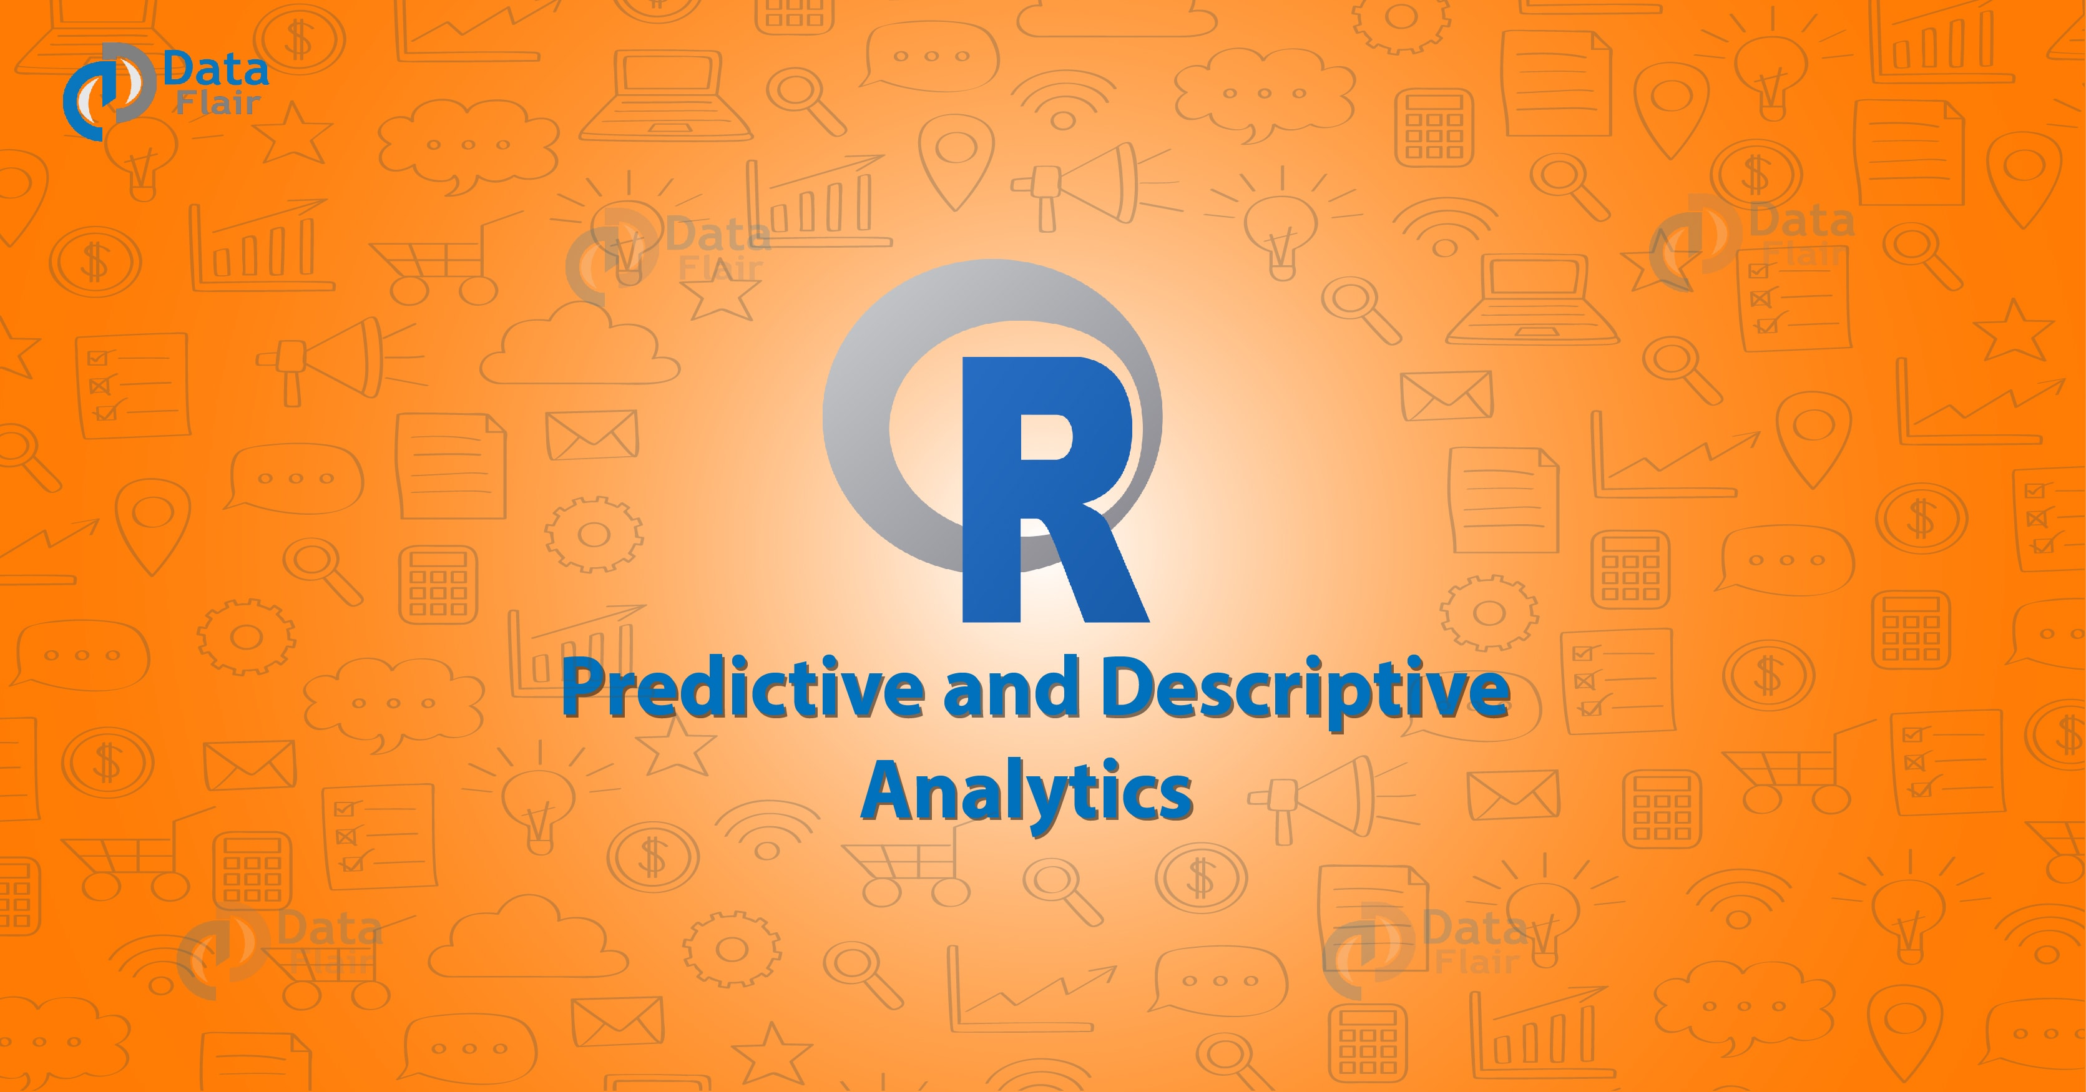](https://d2h0cx97tjks2p.cloudfront.net/blogs/wp-content/uploads/r-predictive-and-descriptive-analytics.jpg)

[Most Important Reasons why you should learn R programming?](http://data-flair.training/blogs/why-you-should-learn-r-programming/)

**2. R Predictive and Descriptive Analytics Introduction**

Let’s first discuss Predictive Analytics in R along with their process and Applications.

**2.1. What is Predictive Analytics?**

**Predictive analytics** is the branch of advanced analysis. It is used to make predictions about unknown future events. The Predictive analysis contains data collection, statistics, and deployment. It uses many techniques from data mining, statistics,[**machine learning**](http://data-flair.training/blogs/machine-learning-tutorial/) and analyzes current data to make predictions about future. It also allows the business users to create Predictive intelligence.

**2.1.1. Predictive Analysis Process**

Here we will discuss the complete process of it and will learn about an individual point.

* **Define Project** -It includes Project outcomes, business objectives, deliverables, scoping of the effects.
* **Data Collection –** For predictive analysis, it collects data from different sources to analysis. Thus it provides a complete view of customer interactions.
* **Data Analysis** – It is the process of cleaning, transforming, inspecting and modeling data. The goal of this process is to discover useful information.
* **Statistics** – This process enables to confirm the assumptions. Hence it uses the assumption to test using a statistical model
* **Modeling** – An accurate predictive model about future is been created using predictive modeling. There are also options to choose the best model.
* **Deployment** – To deploy the analytical results into everyday decision-making.
* **Model Monitoring** – To ensure that it is providing an expected result, we have to manage model.

**2.1.2. Why we need Predictive Analysis?**

**a) Secure a competitive Stronghold –**It helps you to play your competitors’ weaknesses and company’s strengths. Hence, it allows you to check the actions of consumers and your competitors’ marketing and sales.

**b) Do more than evaluating the past –**Employee analysis helps to check your company details. It will summarize past failure or past success. Therefore, the most important thing is that predictive analysis helps in learning from past experiences.

**c) Maintain business integrity by managing fraud –**First of all, Fraud investigators can look into only a set number of cases each week. Secondly, they use company’s past experience to score transactions according to their level of risk.

**d) Advance your core business Capability –**The next step to growth is to improve company core offering. Thus At its core, it focuses on using it to optimize your approach to the market.

**2.1.3. Applications of Predictive Analytics**

Here we will discuss the used applications of predictive analysis.

**a) Customer Relationship Management** – it helps to achieve objectives such as customer services, Marketing. Analytic customer relationship management applied throughout the customer lifecycle.

**b) Collection analysis** – Predictive analysis optimizes the collection of allocation resources. It also helps in increasing the recovery and also reducing the collection costs.

**c) Fraud detection** – it can find inaccurate credit applications and identify false claims.

[](https://data-flair.training/blogs/r-interview-questions-and-answers/)

**d) Health Care** – Here it determines the patients who are at risk.

**[Test Your R Knowledge](https://data-flair.training/blogs/category/quiz/r-quiz/" \t "_blank)**

**2.2. What is Descriptive Analytics?**

After studying Predictive Analytics, let’s now discuss Descriptive Analytics in detail.

Descriptive Analytics: Insight into the past

It does exactly what the name Implies “Describe”. it allows us to learn from our past and to understand how they might influence future outcomes. The main goal of is to find out the reasons behind previous success or failure in the past. Hence, Most of the social analysis is descriptive analysis.

For Example – the company’s production, financials, operations, sales, finance, inventory, and customers.

**2.2.1. Descriptive Analysis Methods**

**a) Observation Method** – There are two ways to draw meaningful conclusion

* Artificial
* Natural

**b) Survey Method** – In this method, questionnaires prepares and given to the participants. Hence After receiving the answers, the research preceded and results concluded.

**c) Case Method** – It involves a deep study on all the problems discussed. Thus, it makes us understand a particular situation.

**3. Conclusions**

We have studied about the Predictive Analytics and Descriptive Analytics in detail. From above-mentioned information, it is clear that what does both analyses means. Looking at all analytic options can be a difficult task. No one type of analysis is better than another, and in fact, they co-exist with and complement each other.

If you have any query about R predictive and descriptive analytics, so feel free to share with us. We will be happy to solve them.